**Temperature Calibration FZ Planning.**

# Solution I: Temperature display correction only.

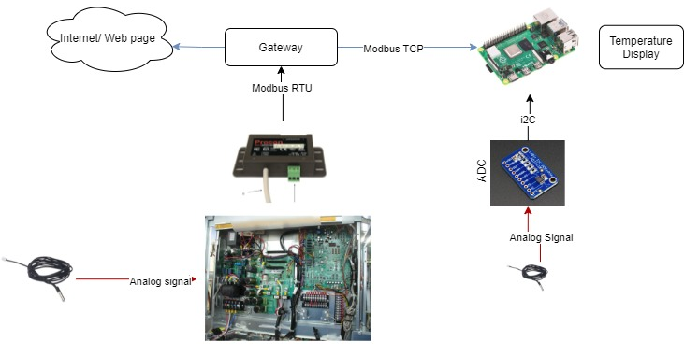

Figure 1.1: Temperature display with raspberry Pi.

|  |  |  |
| --- | --- | --- |
| **Tasks** | **Hours Planning** | **Note** |
| Research on suitable components and ordering the materials. | 2 |  |
| Make a test setup.   * Hardware * Software | 22 | The time planning can be shifted a bit, depend on the deliverable of the components. |
| Testing the setup with FZ | 8 |  |
| Discussion and planning hours. | 4 |  |

|  |  |  |  |  |  |  |  |
| --- | --- | --- | --- | --- | --- | --- | --- |
| 25/06/2021 | | 05/07/2021 | 12/07/2021 | 19/07/2021 – 22/08/2021 | | 23/08/2021 | |
|  |  | |  | |  | |  | |
|  |  | |  | |  | |  | |

Software

Build the hardware setup.

Test the setup with FZ

Project begins

Holiday weeks

Figure 1.2: Solution 1 Timeline.

# Solution 2: Thermistor digital behavior simulator.

Figure 2.1: Thermistor simulator.

|  |  |  |
| --- | --- | --- |
| **Tasks** | **Hours Planning** | **Note** |
| Research on suitable components and ordering the materials. | 2 |  |
| Analyze thermal behavior of thermistor and the interaction with heat pump. | 24 |  |
| Research on connection possibilities (wire/wireless) and the possible range of the connection. | 24 |  |
| Make a test setup to simulate the thermistor behavior.   * Hardware. * Software. * Virtual testing. environment. | 48 |  |
| Test the (research) setup.   * The behavior. * The connection and stability. | 24 |  |
| Installing and testing at Factory Zero with real heat pump. | 16 |  |
| Discussion and planning. | 6 |  |

|  |  |  |  |  |  |  |
| --- | --- | --- | --- | --- | --- | --- |
| 25/06/2021 | 12/07/2021 | 19/07/2021 – 22/08/2021 | | 01/09/2021 | 17/09/2021 | 30/09/2021 |
|  |  |  |  | |  |  |
|  |  |  |  | |  |  |

Research/analyze thermal behavior of thermistor

Project begins

Holiday weeks

Build the test setup

Testing with FZ setup

Testing the setup behavior internally

Figure 2.2: Solution 2 Timeline.